7.3.12 Editors - 3D View - Sidebar - Tool Tab - Grease Pencil - Draw Mode
Draw Mode 3
Brush Panel 3
Brush Browser 3
Create Presets 3
Custom Icon 3
Brush Name Edit Box 3
Brush settings Panel 4
Header - Add Brush Preset 4
Material Browser 4
Dropdown box 5
Edit Box 5
With Draw Tools 5
Radius 5
Use Pressure 5
Strength 5
Use Pressure 5
With Fill Tool 5
Leak Size 6
Thickness 6
Simplify 6
With Eraser Tools 6
Radius 6
Use Pressure 6
Occlude Eraser 6
Mode 6
Disssolve 6
Point 6
Stroke 6
Display Cursor 6
Brush settings Panel - Advanced Subpanel 6
With Draw Tool 6
Input Samples 6
Active Smooth 7
Angle 7
Factor 7
Border Opacity Factor 7
Aspect Ratio X / Y 7
With Fill Tool 7
Boundary 7
Show Lines 7
Resolution 7
Ignore transparent Strokes 7
Threshold 7
Brush settings Panel - Stroke Subpanel 8
Post Processing 8
Smooth 8
Iterations 8
Smooth Thickness 8
Iterations 8
Subdivision Steps 8
Randomness 8
Simplify 8
Trim Stroke Ends 8
Randomize 8
Pressure 8
Strength 9
UV 9
Jitter 9
Use Pressure 9
Stabilize Stroke 9
Radius 9
Factor 9
Brush settings Panel - Curves Subpanel 9
Navigation elements 9
Zoom in and out 9
Tools 9
Reset View 10
Vector Handle 10
Auto Handle 10
Auto Clamped Handle 10
Reset Curve 10
Use Clipping 10
Delete Points 10
Brush settings Panel - Cursor Subpanel 10
Show Fill Color while drawing 10

Draw Mode

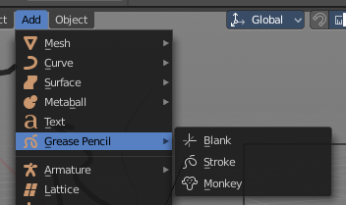
Just the grease Pencil object has a Draw mode.

The Grease Pencil Object allows you to draw in 2D in the workspace.

It starts as an object type. By switchting into paint mode it becomes a paint feature. And editing turns it into a curve or a mesh object then.

In the Tools tab you will find all the options and settings for drawing and manipulating the grease pencil object, means your drawing.

The type Blank allows you to draw strokes.
The type Stroke allows you to draw filled forms.
The type Monkey is just an example object.

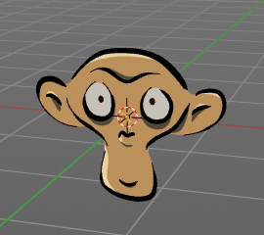
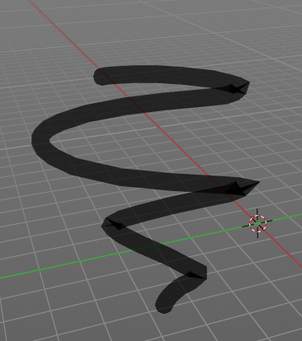
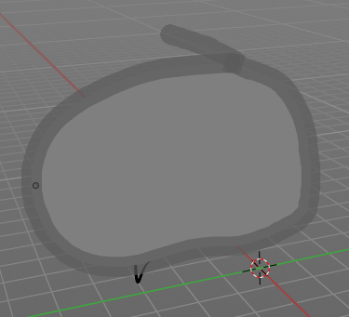

Brush Panel
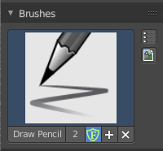

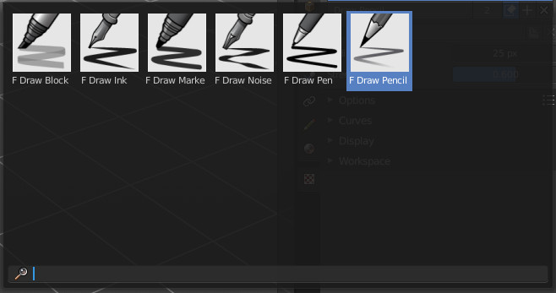
Brush Browser
Here you can choose between the different draw, fill and erase brushes. It's the same than in the tool shelf.

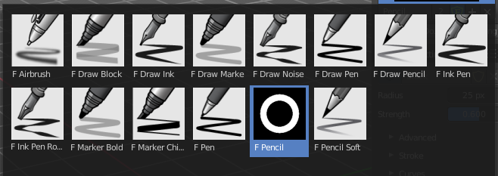

Create Presets
Here you can create a brush preset set that you can further modify.

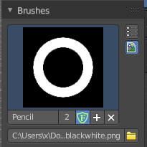
Custom Icon
The button at the right allows you to load a custom icon for your brush. It reveals a file browser below the image browser.

Brush Name Edit Box
The edit box below the Image shows you the name of the current active brush.
The number right of it, in this case 2, indicates how much number of users ( internally ) this brush uses. This means that this data block (the brush) shares currently settings with at least one other object. Most probably the parent brush where we have created it from. Click at the value to make this brush a single user. The button will vanish then.
Fake User set the brush to have a fake user. Zero user data-blocks are normally not saved. But sometimes you want to force the data to be kept even when the data block has no user.
The + button allows you to add a new pencil with the current settings. Note that the brushes are NOT saved when you close Bforartists. You can save them into the current blend file. Or you can save the startup file. But be careful here. This saves everything else of the current state of Bforartists too.
The X button deletes the brush as the active one. It does NOT delete it from the brushes list.

Brush settings Panel

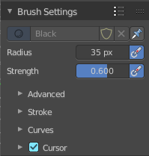

Header - Add Brush Preset
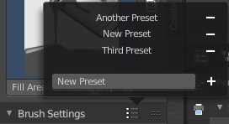
In the header is a brush preset menu where you can store and load custom brush presets. The dialog should be self explaining. In the edit box you type in the name of your new preset. And with clicking at the + button the new preset gets stored. Existing presets can be removed by clicking at the - button at the right side of the preset.

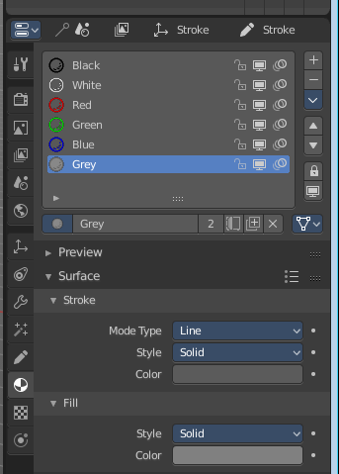
Material Browser
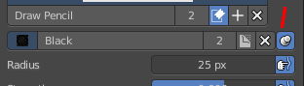
This browser is just active when the Keep material assigned to Brush Pin is activated.
The colors for the grease pencil are materials each. For the grease pencil type Blank you will just have one color available. For this type you have to cteate new matertials in the material tab first when you need more colors. But the other two types, strokes and monkey, comes with a few base materials already. Which can be found in the Materials tab.

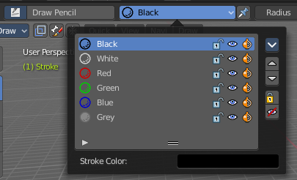
The tool settings above the header shows this panel too. And here you can quickly change the color of a material. It is explained in the chapter Materials Tab.

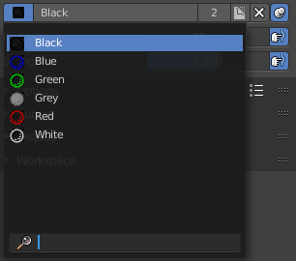
Dropdown box
Here you can choose another material to draw with.

Edit Box
Here you can read and modify the material name.
F set the material to have a fake user. Zero user data-blocks are normally not saved. But sometimes you want to force the data to be kept even when the data block has no user.
The X button deletes the material as the active one. It does NOT delete it from the materials list.
Keep material assigned to Brush Pin pins the brush to this material.

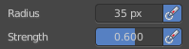
With Draw Tools

Radius
The Radius edit box allows you to adjust the radius of the brush.

Use Pressure
The button behind the edit box enables tablet pressure sensitivity for radius.

Strength
The Strength edit box allows you to adjust the strength of the brush.

Use Pressure
The button behind the edit box enables tablet pressure sensitivity for strength.

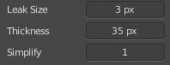
With Fill Tool
Note that the Fill tool does not fill an existing stroke like you would expect. It extends existing strokes with closed areas, or the border.

Leak Size
Size in pixels to consider the leak closed.

Thickness
The thickness of the new created stroke drawn with the fill tool around existing strokes or the border.

Simplify
Number of simplify steps.

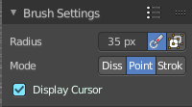
With Eraser Tools

Radius
The radius of the eraser brush.

Use Pressure
The button behind the edit box enables tablet pressure sensitivity for strength.

Occlude Eraser
Erase only visible and not occluded strokes.

Mode

Disssolve
Erase strokes, fading their points strength and thickness.

Point
Erase stroke points.

Stroke
Erase entire strokes.

Display Cursor
Show the eraser cursor.

Brush settings Panel - Advanced Subpanel

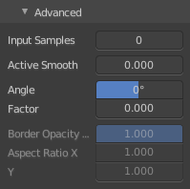
With Draw Tool

Input Samples
Generate intermediate Points for very fast mouse movements. A value of 0 means this feature is disabled.

Active Smooth
The amount of smoothing the strokes while drawing.

Angle
Direction of the stroke at which it gives the biggest thickness.

Factor
Reduce the brush thickness by this amount when the stroke is perpendicular to "Angle" direction.

Border Opacity Factor
Amount of transparency (alpha) to apply from the border of the point to the center. Works only when the brush is using stroke materials of Dot or Box style.

Aspect Ratio X / Y
The width and height of the alpha gradient.
It is unfortunately not to find out where this ominous Dot or Box Style material is to find or to create. So please ignore this settings for now. They are greyed out anyways. Maybe this will solve itself at a later development state.

With Fill Tool

Boundary
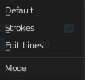
The mode to draw the boundary lines.

Show Lines
Show help lines for filling to see boundaries.

Resolution
Multiplier for the fill resolution. Higher resolution is slower but more accurate.

Ignore transparent Strokes
Show transparent lines to use as boundary for filling.

Threshold
Threshold to consider a color as transparent for filling.

Brush settings Panel - Stroke Subpanel

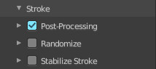
Here you will find some further stroke related settings. It has three sub sections. Post Processing, Randomize and Stabilize Stroke.

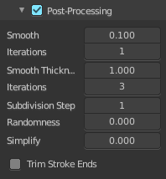
Post Processing
Here you find some post processing settings for new strokes.

Smooth
The smooth amount to reduce jittering.

Iterations
Number of iterations to smooth new created strokes.

Smooth Thickness
Amount of thickness smoothing to reduce jittering.

Iterations
Number of iterations to smooth new created strokes.

Subdivision Steps
Number of subdivisions of new created strokes

Randomness
Randomness factor for new created strokes after subdivision.

Simplify
Simplify new created strokes.

Trim Stroke Ends
Trim intersecting stroke ends.

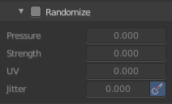
Randomize
Here you can add some randomization to the stroke.

Pressure
Randomize the pressure.

Strength
Randomize the strength.

UV
Randomize the auto generated UV rotation.

Jitter
Add Jitter

Use Pressure
The button behind the edit box enables tablet pressure sensitivity.

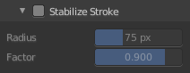
Stabilize Stroke
Draw lines with a delay to allow smooth strokes.

Radius
The minimum distance from last point before the stroke continues.

Factor
Smooth stroke factor. Higher values gives smoother stroke.

Brush settings Panel - Curves Subpanel
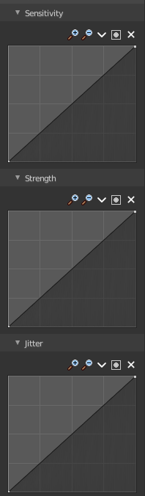
Here you can see and manipulate the curves for drawing Sensitivity, Strength and Jitter.

The navigation elements are the same for all three curve types.

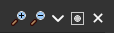
Navigation elements
The navigation elements at the top are described from left to right.

Zoom in and out
The two buttons with the magnifying glass at it zooms in and out in the curve window.

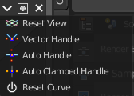
Tools
Tools is a menu where you can find some cuve related tools.

Reset View
Resets the curve windows zoom.

Vector Handle
Set handle type to Vector.

Auto Handle
Set handle type to Auto.

Auto Clamped Handle
Set handle type to Auto Clamped.

Reset Curve
Resets the curve to the initial shape.

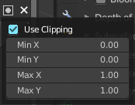
Use Clipping
Clipping options. Here you can set up clipping for the stroke.

Delete Points
Deletes selected curve points.

Brush settings Panel - Cursor Subpanel
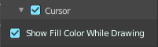
Show the brush cursor under the mouse.

Show Fill Color while drawing
Show the fill color of the grease pencil while drawing.

